Mark Schultz Concert
Saturday, August 25th
Ward Church, 40000 Six Mile Rd., Northville, MI

Mark Schultz songs include:
“Walking Her Home”, “He’s My Son”, “When Love Was Born”,
“I Am”, “Letters from War”
Admission is a full size hygiene item for one of our charities.
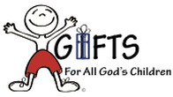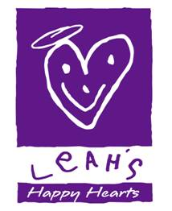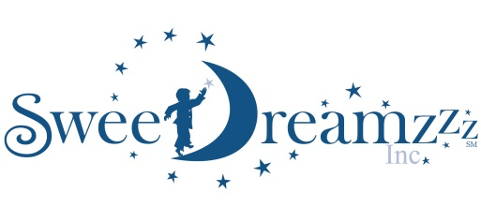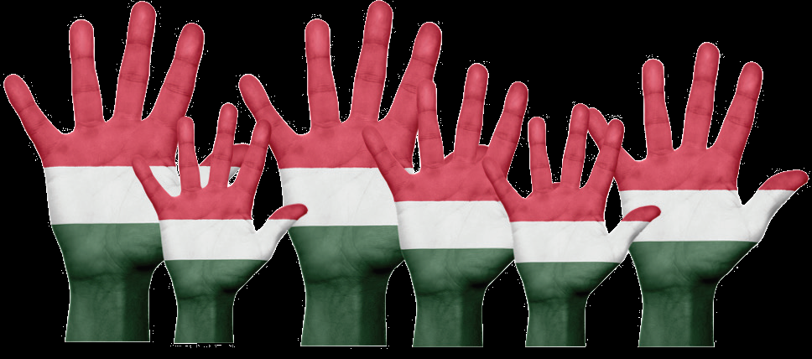
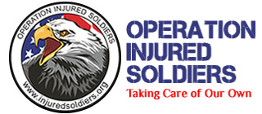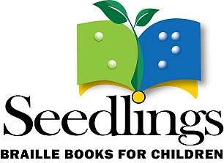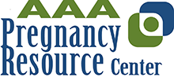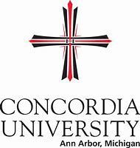

Organizations supported include: Missionary family Goods to Go, Gifts for All God’s Children, Seedlings, Operation Injured Soldiers, Methodist Children’s Home Society, Concordia University Ann Arbor, Redford Interfaith Relief, Leah’s Happy Hearts, Sweet Dreamzzz and others.
Sponsored by Thrivent Community, Livonia
RSVP: https://markschultzthriventcommunity48152.eventbrite.com
Or 734-432-7777

